PF 101 — Object-Oriented Programming
Performance Task
SYSTEM PROPOSAL DOCUMENT
Bantay Barangay: Incident and Complaint Reporting System

Group No.: 4

Section:
PF101A – A

Date Submitted:
September 30, 2026

Instructor:
Harvey Sean Ocmen
SDG Focus:
SDG 16: Peace, Justice and Strong Institutions

1. Group Members

Full Name | Role | Section / Block | Task Assignment
Jenny Monica Lood | Leader | BSIT 3 / Section A | [Role in Project, e.g., UI, DB, Testing]
Markus Vincentius Diong | Member | BSIT 3 / Section A | [Role in Project, e.g., UI, DB, Testing]
Alexes James Cesar | Member | BSIT 3 / Section A | [Role in Project, e.g., UI, DB, Testing]
Sung Joon Lee | Member | BSIT 3 / Section A | [Role in Project, e.g., UI, DB, Testing]

2. Project Name and Description

Project Name
Bantay Barangay: Incident and Complaint Reporting System
Project Description
The Barangay Incident and Complaint Reporting System is a Java-based system designed to help organize the reporting and monitoring of incidents and complaints within a barangay. The system addresses a common challenge in manual reporting, where submitted concerns may be difficult to organize, search, monitor, and follow up. Residents can submit a report by providing its type, category, location, and description. Each submitted report receives a unique Report ID that can be used as a reference when checking its status. Barangay personnel can review reports, update their status, record actions taken, and search existing records.
The system is intended for two main users: residents who submit reports and authorized barangay personnel who manage them. Reports are stored using .txt files as a makeshift database through Java file handling, as required for the project. The system applies Object-Oriented Programming through classes representing users, reports, and report-management operations. Encapsulation, inheritance, polymorphism, and abstraction will be incorporated into the class design. The proposed system focuses on improving the organization and traceability of reports rather than replacing the actual decision-making or procedures of barangay personnel.

3. SDG and Number

Field | Details
SDG Number | SDG 16
SDG Title | Peace, Justice and Strong Institutions
Alignment / Justification | The proposed system supports SDG 16 by promoting organized and accountable handling of community concerns. It provides a structured way to record incidents and complaints, assign each report a unique reference number, monitor its status, and document actions taken by barangay personnel. By keeping an organized record of submitted concerns and their progress, the system can support transparency and more systematic community service. The system does not replace the authority or judgment of barangay officials; instead, it provides an information-management tool that can help them track reported concerns.

4. Class Diagram

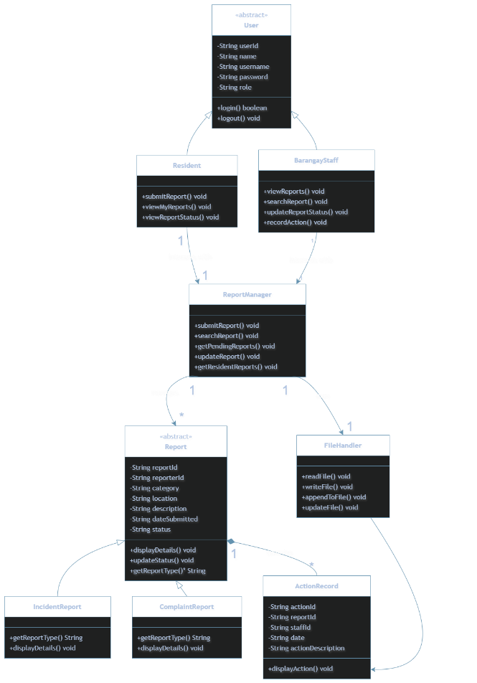

OOP Concepts Applied
OOP Concept | Where Applied in the System
Encapsulation | Attributes within the User, Report, and ActionRecord classes are declared as private. Access and modification of these data points are strictly governed through established getter and setter methods to ensure data integrity.
Inheritance | Both Resident and BarangayStaff inherit foundational attributes and authentication behaviors from the User superclass. Similarly, IncidentReport and ComplaintReport inherit standardized fields from the Report superclass.
Polymorphism | The system can iterate through a collection of generic Report objects while executing subclass-specific behaviors. Invoking the abstract getReportType() method yields dynamic results depending on whether the instance is an IncidentReport or a ComplaintReport.
Abstraction | User and Report are designed as abstract base classes. They define the essential blueprint and mandatory methods for their respective domains while delegating the specific implementation details to their concrete subclasses.

5. Functionalities

# | Functionality | Description / Operations | Data File (.txt)
1 | User Registration & Authentication | Register new users, verify login credentials, and determine system authorization levels | users.txt
2 | Report Submission | Residents instantiate a report by supplying categorical and descriptive data. The system algorithmically generates and assigns a unique Report ID. | reports.txt
3 | Data Query & Retrieval | Residents query their personal submission history. Staff search the entire database using specific Report IDs or parameters. | reports.txt
4 | Status & Action Management | Authorized staff transition report statuses (e.g., Pending to In-Progress) and append chronologically stamped action records outlining steps taken. | reports.txt, actions.txt
5 | Monitoring & Aggregation | The system provides a centralized summary of pending, ongoing, and resolved operational tasks to prevent oversight of community concerns. | reports.txt, actions.txt

. Grading Basis (For Instructor Use)
Instructions: This section is completed by the instructor. Individual member grades are computed separately using the accompanying Grading Workbook (Excel).

Component | Weight | Score
Proposal Documents | 50%
Presentation, System Demonstration & Q&A | 50%
Total | 100%

